Training
OSU provides demand based training services that aim at filling knowledge and skill gaps among public servants on variety of topics. In the past 4 years alone (since 2016), the university has provided short and long term trainings for above 92,000 public servants.
To further strengthen its capacity building services, OSU has established a new center, namely: Center for Professional Competence and Human Resource Development as part of its revised organizational structure adopted in 2019. This has been done particularly following the decision made by Oromia Regional Government giving OSU an exclusive mandate to handle issues of public servant professional competence.
Accordingly, OSU has set out with a renewed sense of mission and a strategic focus reflected in its new 10 years strategic plan (2020-2030) and its 2020/21 annual plan which have already been under implementation.
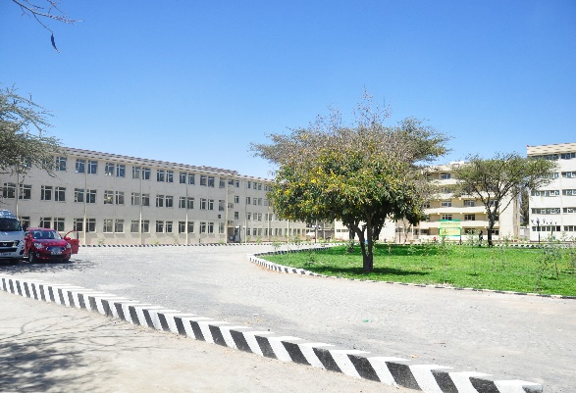
OSU has also done extensive works in expanding and modernizing its training facilities. Among others, the university has built seven new blocks of three story buildings each equipped with top-notch training support facilities such as ACs, LCDs and LED TV that have become operational since 2016. Along with these are also variety of modern training room layouts customized for mass conferences and trainee group discussions.
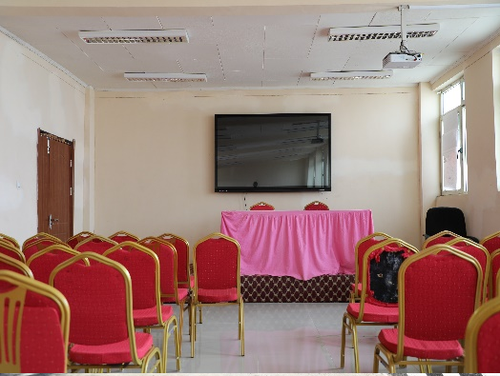
On top of this, the fact that OSU’s campus is located in the immediate vicinity of Lake Dembal provides a still more fascinating opportunity for lake-side recreation and aesthetic experiences to be enjoyed by its trainee customers even during their regular coffee breaks.
The university provides training service to carry out transformation on institutions in particular public service institutions of the region through enhancing the skill, attitude and knowledge. It advocates good governance, rendering public service, capacitating the university community and staff in teaching learning processes as well as other academic issues.

The training is mainly undertaken by the university staff in their field of expertise and experience, and invites scholars/ expertise from various institutions when necessary. The training is currently creating extra work for the staffs and other stakeholders.
Based on the demands and need assessment of various regional and governmental bureaus of the region,the institution has already trained more than 210,000 in 2018/2019 academic calendar. Some of the main themes of the trainings wereBasic managerial concepts and skills,Customer service and customer handling,Customer service and customer handling, Strategic planning and Management, Reform tools (BPR, BSC fi etc.), Kaizen philosophy, Procurement and property administration, Tax and Tax Reform, Computer Hardware and Software Maintenance and Troubleshooting, Employment & Labor Law and the like.
The university also carried training facilitation and coordination activities based on training demands of various organizations. Besides employees of Oromia bureaus, Federal bureaus, non-governmental organizations and various developmental institutions have trained their employees in the university
As the geographic set up of the university is on the shore of Lake Batu/ Zeway, with attractive campus, well equipped training rooms and hospitality OSU is a special experience on training, education, and research.

